What?

* Mutual: more than 2 people.
* Fund : money
* So when more than 2 people come together and put their money for a common purpose, that's called mutual funds.
* Purpose of mutual funds is to earn profit from debt and equity market.
* These people don't have much knowledge about the market nor do they have enough time.
* So they go to some Asset management company (AMC) who have some experienced person to help the people to invest their money in the right place.

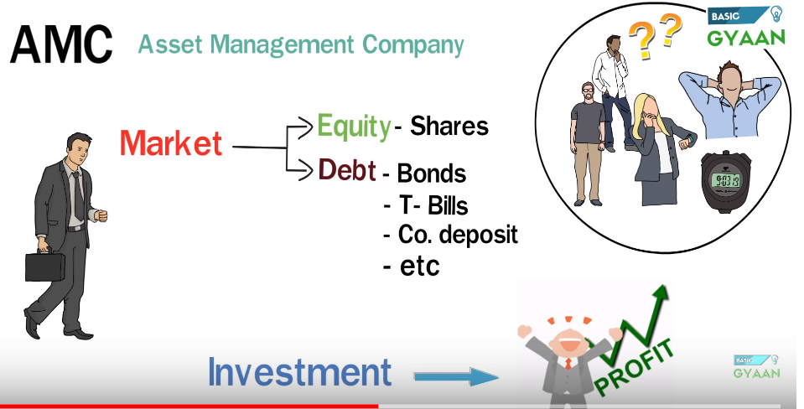

* Two most important aspects of mutual funds are :

1. Risk taking capacity a
2. Investment horizon.

Market Capitalization:

* Helps to understand the size of the company
* 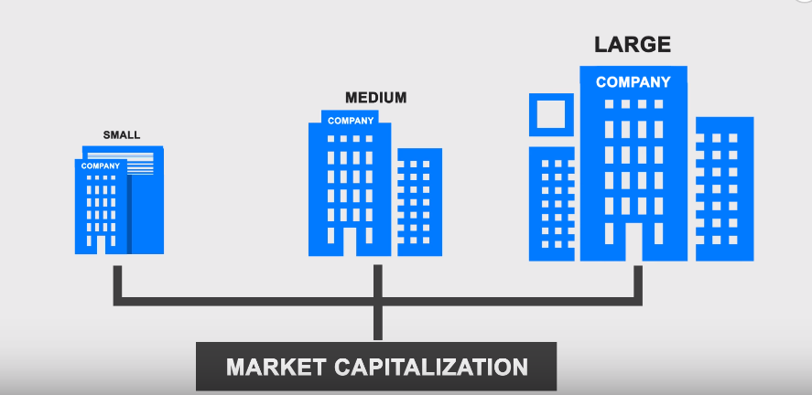

* 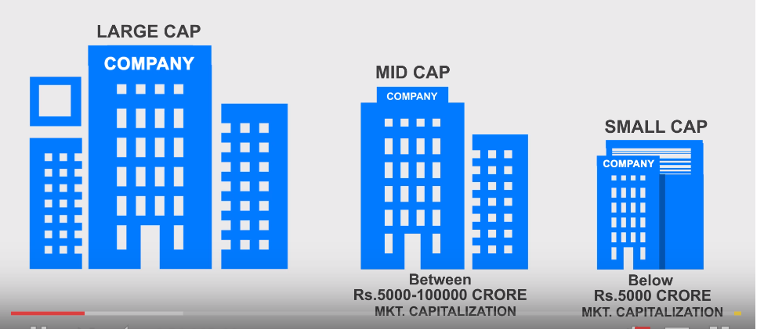

There are 3 types of mutual funds:

1. **Equity:**

* These are for aggressive investors.
* More risk and more profit.
* These funds invest in stock market.
* Types:

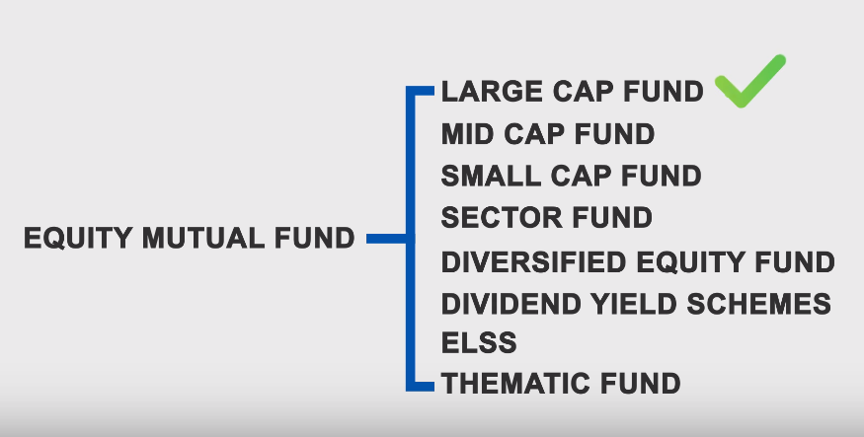

1. Large cap:

* Big and well established companies. With strong market presence.
* They are the leaders in their sector.
* They have good financial strength to survive during bad times. Hence they are less risky than small and mid cap companies.

1. Mid cap
2. Small Cap:

* They have just started developing.
* Chances of both growth and failure is high in case of small cap companies.

d) Sector fund:

* Investing in a particular sector.
* Like Reliance Media and Entertainment fund: Only invests in investment funds.
* SBI pharma funds: Invest in pharma sector.

1. Diversified Equity Fund:

* Invest in different sectors and different market capitalization funds.

1. Dividend Yield fund:

* Invest in the companies that share their profit with the investors.

1. ELSS (Equity linked savings scheme)

* Tax saving mutual funds.
* Lock in period of 3 years.
* We get 1.5 lakh tax rebate under section 80 CC

1. Thematic funds:

* Invest in themes like ecommerce themes, rural india themes.
* For example. HDFC housing opportunity funds is a Themetic fund which buy stocks related to housing, like cement, construction, paint etc.

1. **Debt:**

* For conservative investors.
* So less risk and less return
* Government or companies borrow the money using debt instruments and return with interest.
* 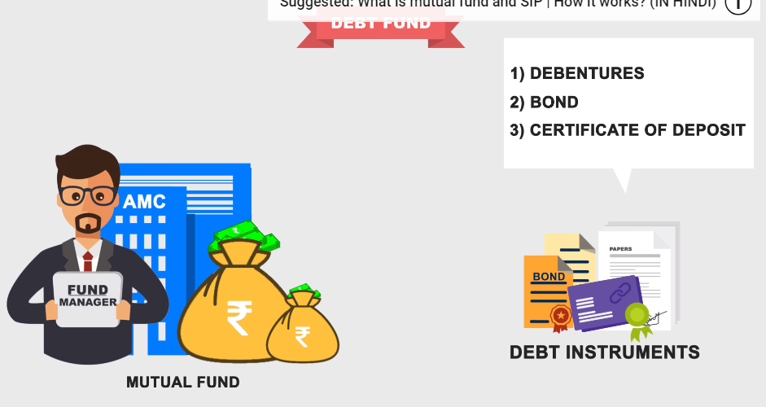

* Types:

1. GILT fund:

* Only invest in government security are called GILT debt fund.
* Since these securities are issued by government the default risk is low.

1. Junk bond schemes:

* Default risk is more.

1. Fixed maturity plan:

* Have a fixed predefined maturity.
* They invest in certificate of deposit, commercial papers and corporate bonds.

1. Liquid funds:

* Best option for short term.

Balanced/Hybrid:

* Mixture of both above:
* Invest in both debt and equity.

